**ASBAT EXAMINATION BOARD**

**END OF TERM III EXAMINATION 2023**

**TOP CLASS: (5 – 6 YEARS)**

**LEARNING AREA 2: LANGUAGE DEVELOPMENT I**

**My name is: ………………………………..………………………….**

**My School is: ……………………………..……….…………………..**

**I am in: ………………………………..…………………………………………..**

1. **Write capital letters**.

a_____ r_____ b_____ h ____ d ____

t_____ e_____ n_____

1. **Read and draw.**

|  |  |
| --- | --- |
| It is a basket. |  |
| This is a stool. |  |
| I can see a stone. |  |
| Here is a shoe. |  |
| A boy and a girl. |  |

1. **Use ‘and’ to make sentences.**



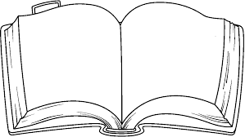

_____________________________

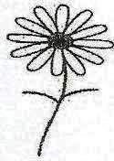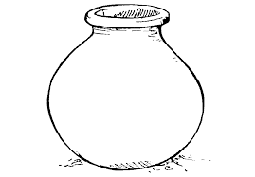

_____________________________

_____________________________

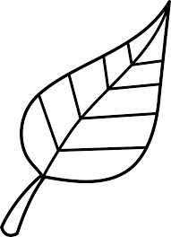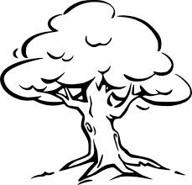

_____________________________

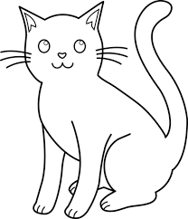

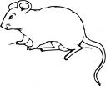

_____________________________

1. **Write ‘a’ or ‘an’.**

_______ bag ______ elephant

_______ apple ______ onion

_______ dress ______ cup

_______ flower ______ insect

1. **What are they doing?**

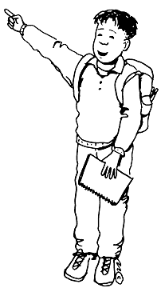

_____________________________

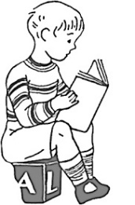

_____________________________

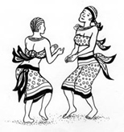

_____________________________

1. 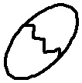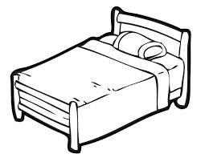**Name these pictures.**

__________ ____________

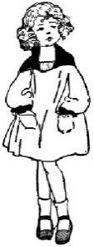

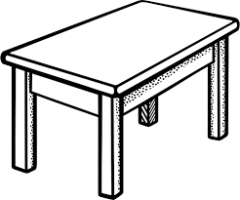 __________ _____________

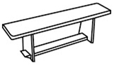 __________

1. **Fill in the missing letter.**

kn___fe w___nd___w

c___r w___ll

t___n a___e

s___n p___nc___l

gr___ss

1. **Write the words correctly**.

ssdre _________________

loost ___________________

bleta ___________________

byo ____________________

airch __________________

eafl ___________________

***“Good Luck”***